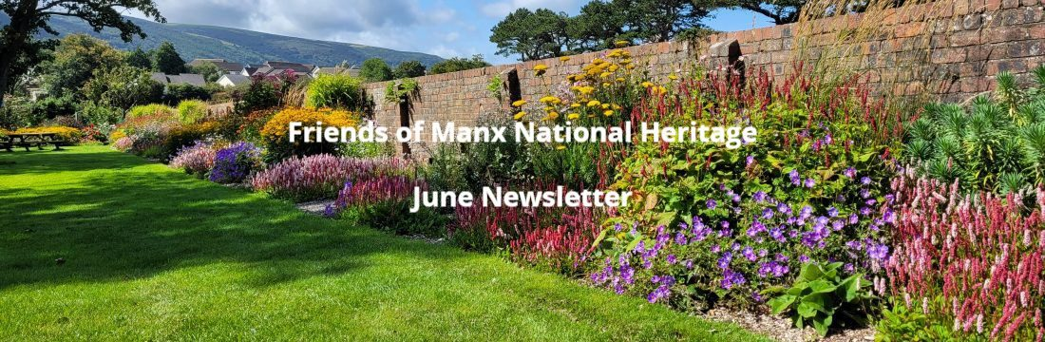

Dear Friends,
Welcome to your FMNH June newsletter. I am delighted to bring you updates and events exclusive to FMNH members. As always, you can find a full list of Manx National Heritage sites and their opening times on the MNH website.
Garden Volunteers
Last week I visited the Friends Garden Volunteers who do such great work in keeping Rushen Abbey looking so splendid. We are very lucky to have such great volunteers at Rushen Abbey, the Grove and Cregneash and I hope to get round the rest of the sites over the summer to meet them. Thank you, Manx National Heritage couldn’t keep the grounds at their sites looking so wonderful without you.
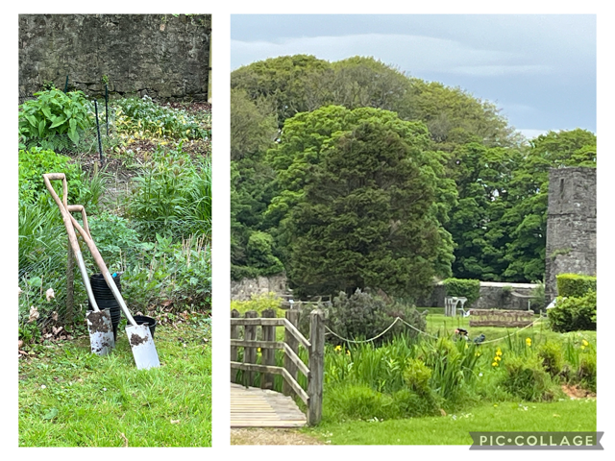
Isle of Man TT
If you would like to find out more about the extraordinary history of the Isle of Man TT and the people involved, why not book a place on our guided tour of the Manx Museum’s TT Gallery? https://www.friendsofmnh.org/events/

Corporate Memberships
Thanks to Thomas Miller, who have renewed their Corporate Membership of FMNH, offering 40 of their staff and families the benefits of Friends membership and supporting our unique Island heritage.

Reminder
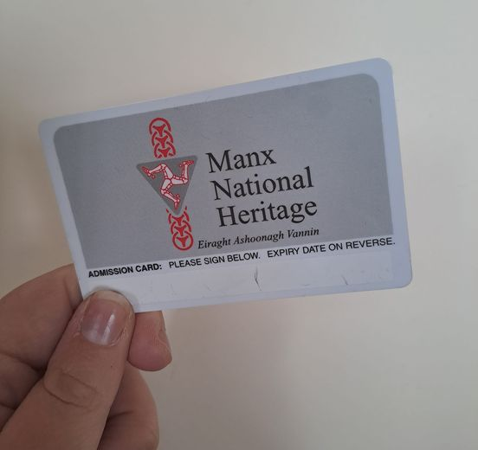
A friendly reminder to please renew your FMNH memberships in good time if you are planning to use them when you travel off island. We will always try our best to get your membership cards to you as soon as we can, but please check the expiry dates on your cards well before your planned trip. Thank you!
Manx National Heritage TT News
The limited edition 2024 souvenir TT Pin Badge is now on sale for just £8 at MNH sites and online. There is also a ‘pop up’ TT merchandise shop at the Manx Museum over the race fortnight, with 30% off some stock.
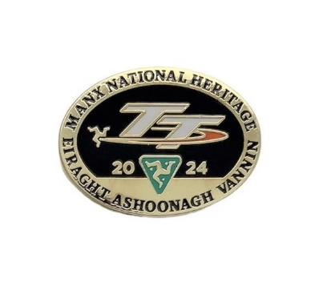
Manx National Heritage Exhibitions and Events
‘Tynwald Week - Photos by Martin Parr’ - From 29th June to 6th October at the Manx Museum a free exhibition showcasing photographs captured by British documentary photographer Martin Parr.

‘All at Sea’ - Until 26th January 2025 at the House of Manannan: a free exhibition exploring the Isle of Man’s maritime heritage and celebrating 200 years of the RNLI.

‘Wild Mann Nature Photographer’ - until 23rd June at the Museum; a free exhibition of over 50 of the best images from the Wild Mann Nature Photography competition.

Laxey Wheel Hard Hat Tours: ‘Rods and Rockers’ – selected dates until 7th September. Join MNH at the Great Laxey Wheel for a behind the scenes look at the second phase of conservation work on the rod duct, T Rocker and bogies. £20. Book here
Friends Events to Book Now
Guided Tour – ‘Curating and Conserving the TT Gallery’: Join MNH Curator Matthew Richardson and Conservator Chris Weeks to hear more about the fantastic artefacts on display and learn about the vibrant history of the TT races on the Isle of Man. Matthew's extensive knowledge of the history of motorsport will provide you with a whole new way to experience the Gallery, even if you have visited before. Chris will share some of the challenges and innovations involved in getting the gallery's objects ready for display.
Date: Thursday 13th June 2024, 11:00am. Price: £12
Venue: The Manx Museum TT Gallery. Only 8 places left
Illustrated Talk – ‘Watch and Ward’: For hundreds of years before radar and telescopes, it was a legal requirement for Manxmen to keep an organised watch out to sea for signs of potential trouble. MNH Archaeologist Andy Johnson will review the known facts about this system of watch-keeping and present new evidence of how it functioned and where the watch-sites were located.
Date: Thursday 11th July 2024, 10:30am. Price: £10
Venue: The Manx Museum. Max places: 40
Guided Tour – ‘Secrets from the Rushen Abbey Excavations’: Dr. Peter Davey of Liverpool University and formerly the Centre for Manx Studies has spent many years excavating at Rushen Abbey. His book ‘Rushen Abbey: 100 years of excavation’ has just been published. Join Peter at the Abbey for a guided stroll around the gardens as he shares fascinating insights into this historic site and enjoy strawberries and cream (hopefully in the sunshine!)
Date: Wednesday 17th July 2024, 2 pm. Price: £15
Venue: Rushen Abbey, Ballasalla. SOLD OUT
Guided Tour – the Grove Gardens: Embark on an exclusive journey with Philip Payne, MNH Horticultural Manager, through the Grove Gardens. This guided tour offers a unique glimpse into the garden's past, illustrated with historical images. Witness the transformation achieved with our dedicated volunteers, as we unveil the efforts undertaken to restore the garden's beauty. Delve into the challenges we've faced, and the vision we hold for the future. Afterwards, enjoy a cuppa and biscuits while you browse some historic photos and planting plans in the conservatory, where Philip will be available to answer questions and help with any general gardening queries you may have.
Date: Friday 2nd August 2024, 2.30pm. Price: £15
Venue: The Grove, Ramsey. Only 6 places left
Illustrated Talk - Art vs. Archives: Join Emma Le Cornu to discover how a paper conservator thinks and acts on different collections at the Manx Museum. Illustrated with stories of items from the collections.
Date: Thursday 15th August 2024, 10:30am. Price: £10
Venue: The Manx Museum. Max places: 40
To Book: Email info@fmnh.im call 07624 243806 or complete the booking form on our website.

