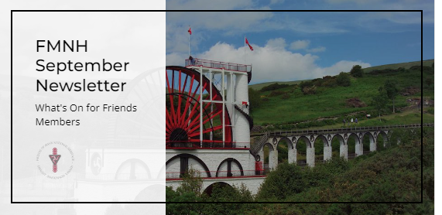

Dear Friends,

Welcome to your FMNH September newsletter. I am delighted to bring you updates and events exclusive to FMNH members. As always, you can find a full list of Manx National Heritage sites and their opening times on the [MNH](https://manxnationalheritage.im/visit-2/) website.

**Friends Events to Book Now**

**Illustrated Talk - Isle of Man Shipwrecks Project:** Join Jude Dicken to explore how MNH, working with researcher Adrian Corkill, has made centuries of wreck stories available online for the first time in 2023/24 on [the Isle of Man Historic Environment Record](https://isleofmanher.im/) and as part of the UK wide [‘Unpath’d Waters’](https://unpathdwaters.org.uk/) project.

**Date:** Thursday 19th September 2024, **10.30am**. **Price:** £10

**Venue:** iMuseum, Kingswood Grove

**Illustrated Talk – From Harvest to Hollantide:** Join former MNH Curator Yvonne Cresswell todiscover more about the traditional (and some more recent) Manx customs to be found around the Island in the autumn months - basically how to get good luck, stop bad luck AND have a good time as well!

**Date:** Thursday 17th October 2024, **10.30am**. **Price:** £10

**Venue:** The Manx Museum

**To Book: Email** [**info@fmnh.im**](mailto:info@fmnh.im) **or call** **07624 243806**

For those of you who had a place booked on our postponed **‘Watch and Ward’** talk on 11th July – I still do not have a new date, but I will email or call you as soon as I know. Thank you for your patience.

**FMNH Annual General Meeting**

The FMNH AGM will be held at the Manx Museum on Saturday 9th November 2024. More details to follow in due course.

**Heritage Open Days 2024**

The Heritage Open Days programme is now available online (bookings open 19th Sept):

<https://manxnationalheritage.im/whats-on/detail/heritage-open-days-2024/>

**Bookings open at 12 noon on 19th September and the Eventbrite booking link will be released on MNH’s and FMNH’s socials. You will not be able to book through FMNH, or before this time.**

Thank you to all the FMNH members who have volunteered to help with stewarding for Heritage Open Days. Katie King tells me that she now has enough volunteers.

**Volunteers Needed**

Would you like to help out at the following Manx National Heritage Events? If so, please email [di.williams@mnh.im](mailto:di.williams@mnh.im) and copy me in ([emma@fmnh.im](mailto:emma@fmnh.im))

**Celebrating 170 Years of the Laxey Wheel**

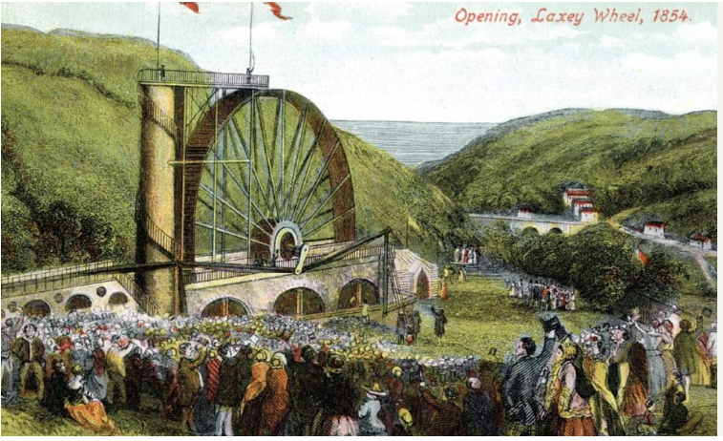

Saturday 28th September 2024 at the Laxey Wheel. The event will run from 2pm to 4pm. MNH are looking for 3 or 4 volunteers to assist with things such as the lawn games and the shop. There will be traditional games, a special 170th anniversary trail and talks by Historic Buildings Architect John-Paul Walker. If you would like to volunteer, please email [di.williams@mnh.im](mailto:di.williams@mnh.im) and copy me in.

**Hop Tu Naa Festival Day at Cregneash**

Sunday 27th October 2024 at Cregneash. The event runs from 10am to 3pm and a lunch will be provided for volunteers. Volunteers are needed to assist with things such as car parking and stewarding individual events around the site. If you would like to volunteer, please email [di.williams@mnh.im](mailto:di.williams@mnh.im) and copy me in.

**Little People’s Picnic Volunteers – Thank You**

Many thanks to the Friends volunteers who kindly helped out at the Little People’s Picnic. A good time was had by all (despite the weather).

**Early Christmas Shopping?**

**The 2025 Manx National Heritage Calendar is available now!**

Featuring full colour images of a selection of Manx National Heritage sites, this 2025 A4 calendar features all Bank and Manx holidays. Every purchase of the 2025 calendar helps to look after Manx National Heritage historic sites, countryside and treasures.

Purchase your copy here: [https://manxnationalheritage.im/.../2025-manx-national.../](https://manxnationalheritage.im/shop/product/2025-manx-national-heritage-calendar/?fbclid=IwZXh0bgNhZW0CMTAAAR0QlJVVxykE-Q-717kcKDIKH8Msmi5wesvchO9Yacixq7eZ7S8JWE9iP7A_aem_2vp4E6C0M0ih4iu8lhdW8Q)

**Manx National Heritage Exhibitions and Events**

[**Laxey Wheel 170th Anniversary Celebrations:**](https://manxnationalheritage.im/whats-on/detail/laxey-wheel-170th-anniversary/)A free event for all the family to celebrate 170years of the Laxey Wheel. Traditional games, 170th anniversary trail, expert talks by Historic Buildings Architect John-Paul Walker and Hard Hat Tours (pre-bookable tickets available to purchase in advance). Saturday 28th September 2024, 12.30 - 3.30pm.

[**Turn Up for Turnips!**](https://manxnationalheritage.im/whats-on/detail/turn-up-for-turnips/)Head to Cregneash and carve your turnip lantern in time for Hop tu Naa. 28/10/2024 - 31/10/2024. Standard admission applies (free to FMNH members), small additional charge for turnips.

[**Tales from the Crypt – Children’s Tour:**](https://manxnationalheritage.im/whats-on/detail/tales-from-the-crypt-childrens-tour/)This half term**,** enjoy a children’s tour of Peel Castle with a twist and learn the myths and legends of St Patrick’s Isle. 29th October 2024, 11am and 1pm. £8, price includes 1 adult free per ticket.

[**Manx Folklore – Rare Sightings and Urban Faeries:**](https://manxnationalheritage.im/whats-on/detail/manx-folklore-rare-sightings-and-urban-faeries/)Step into the realm of Manx fairy tales, myths and legends in a unique exhibition by artist and illustrator Julia Ashby-Smith**.** 26th October 2024 until 23rd February 2025 at the Manx Museum. Free, donations welcome.

[**Labyrinth – All at Sea**](https://manxnationalheritage.im/whats-on/detail/labyrinth-all-at-sea/)**:** A new promenade performance at the House of Manannan. Two hundred years ago, Sir William Hillary founded the RNLI, motivated by witnessing losses of ships and lives around the Isle of Man. Around 2,000 shipwrecks have been recorded in Manx waters, but their stories have not been lost. Inspired by historical events, come along and hear maritime tales of tragedy, bravery, survival, and a little looting! Come aboard and embark upon an immersive and thought-provoking journey through our maritime heritage. 14th November 2024 to 16th November 2024. Tickets £18 – book[**here**](https://manxnationalheritage.im/shop/product/labyrinth-all-at-sea-14th-15th-16th-november/)

[**Manx Olympians**](https://manxnationalheritage.im/whats-on/detail/manx-olympians/)**:** An exhibition celebrating athletes from the Isle of Man who have achieved success at the Olympics – and future rising stars. Manx Museum until 23rd February 2025. Free, donations welcome.

[**Tynwald Week**](https://manxnationalheritage.im/whats-on/detail/tynwald-week-photos-by-martin-parr/): Photos by Martin Parr: Ann exhibition showcasing photographs captured during Manx National Week 2023 by British documentary photographer Martin Parr. Manx Museum until 6th October 2024. Free, donations welcome.