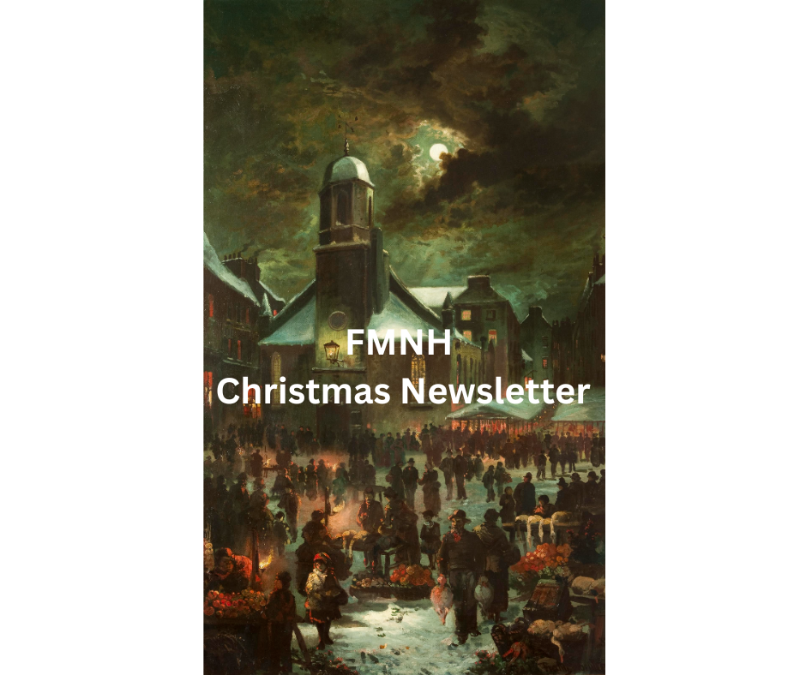
Image: Goose Fair, Old St Matthew’s Church. iMuseum https://bit.ly/3V04wkx

Dear Friends,
Welcome to your FMNH December newsletter. I am delighted to bring you updates and events. As always, you can find a full list of Manx National Heritage sites and their opening times on the MNH website. Although MNH’s seasonal sites are closed for the winter, the Manx Museum and House of Manannan remain open all year and there’s plenty going on.

FMNH 14th Annual General Meeting
The 14th Annual General Meeting took place on November 9^{th,} and it was a pleasure to see members there. The Minutes will be available on our website shortly or by request from me emma@fmnh.im or 07624 243806.
A resolution to increase the Membership Fees from 1st February 2025 was proposed and the Meeting approved the resolution. (Price rise to take effect 1st February 2025)
Category | 2024 Price | Price After Increase
Single annual member | £40 | £45
Additional annual member | £30 | £35
Child member | £6 | No increase
10 Year member | £400 | £425
10 Year additional member | £255 | £275
Life member | £1250 | No increase

If you pay by annual direct debit, we will make the necessary adjustment to your payment. Please contact me if you have any questions.

Manx National Heritage Christmas Cards
Available online or at the MNH shops, these are available in packs of 10 featuring two different Manx Christmas scenes (The Goose Fair by Franz Hoepfner and Peel Church December 1890 by George Goodwin) priced at £6 per pack. https://manxnationalheritage.im/shop/

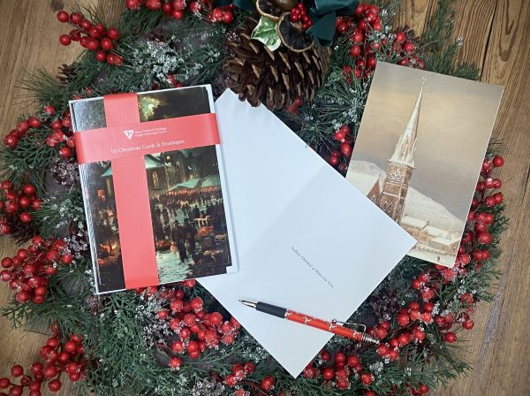

Manx National Heritage Exhibitions and Events

Events for Families
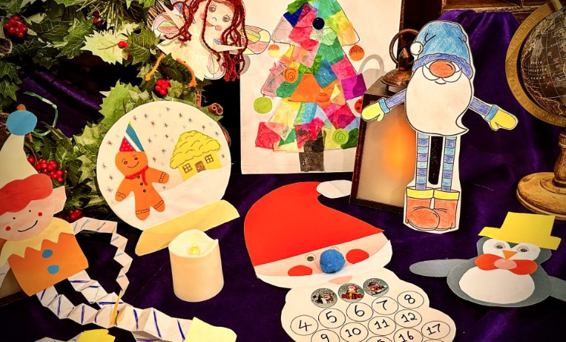
From ‘Little Screen Fridays’ to Christmas Crafting at the Manx Museum, there’s plenty of family fun to be had with Manx National Heritage as we head towards Christmas. See MNH website for details: https://manxnationalheritage.im/whats-on/

New for 2025 – Gaiety 125
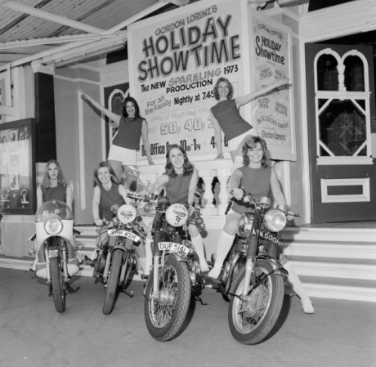
An exhibition celebrating the 125th anniversary of one of the Isle of Man’s most loved buildings, the Frank Matcham designed Gaiety Theatre. Date: 25/01/2025 -18/05/2025. 9.30am - 4.30pm at the Manx Museum. Free admission – Donations welcome.

New for 2025 – 6 Contemporary Art Exhibition
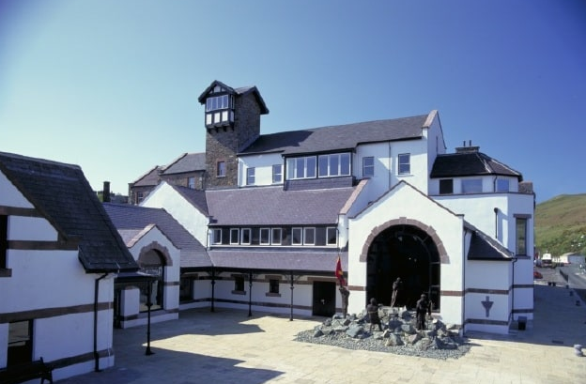
Six contemporary Manx artists: Sally Black, Petrina Kent, Ella Magee, Helen Faragher, Ellie Baker and Ongky Wijana showcase their works on paper, canvas and in stone.
Date: 15/02/2025 - 27/04/2025. 9.30am - 4.30pm at the House of Manannan. Free admission – Donations welcome.

New for 2025 – Archibald Knox Order & Beauty

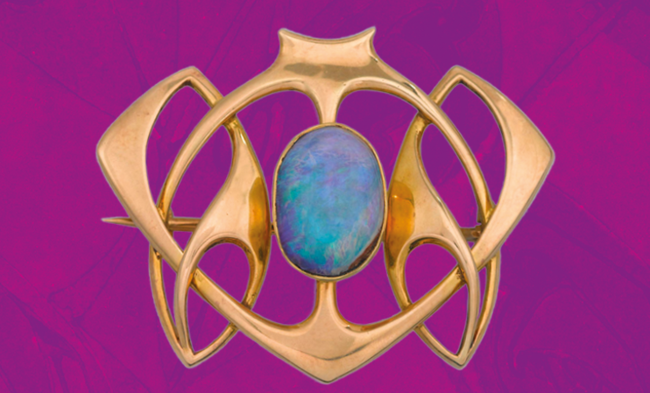
In 2025 the world’s largest exhibition of works by Archibald Knox is set to be showcased in the National Art Gallery at the Manx Museum. Knox: Order & Beauty will open on 5th April 2025. There will also be a whole host of special events to accompany the exhibition, including a series of talks, tours and walks in the footsteps of Archibald Knox – see MNH website for more details: https://manxnationalheritage.im/whats-on/

New for 2025 – ‘No Limit’ at 90


An exhibition marking the 90th anniversary of the release of one of the Isle of Man TT’s best loved tributes. The 1935 film 'No Limit' starred Britain’s top comedian at that time, George Formby, as aspiring TT rider George Shuttleworth. Date: 24/05/2025 - 07/09/2025. 9.30am - 4.30pm at the Manx Museum. Free admission – Donations welcome.

Friends of Manx National Heritage Membership Cards
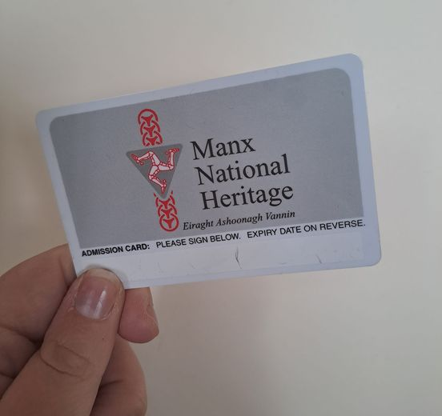
Please remember that your Friends Membership Card is valid for use only by the person named on the card and be prepared to provide proof of your identity at sites if requested.

Your membership is vital to our mission, and we are grateful for your continued support. Together, we are safeguarding the heritage of the Isle of Man for future generations to cherish.
Please contact Emma emma@fmnh.im or call me on 07624 243806 if you would like any more information about our events and news. I work part time, but if you leave me a message I will return your call as soon as I can.
It only remains for me to wish you a very merry Christmas and a peaceful New Year from me and the Board of Directors at the Friends of Manx National Heritage.
Kind regards,
Emma

Website: Friends of Manx National Heritage https://www.friendsofmnh.org/
Follow our Facebook page: https://www.facebook.com/friendsofmnh/
Follow our LinkedIn page: https://www.linkedin.com/company/friends-of-manx-national-heritage/
Follow us on Instagram: friendsofmnh

