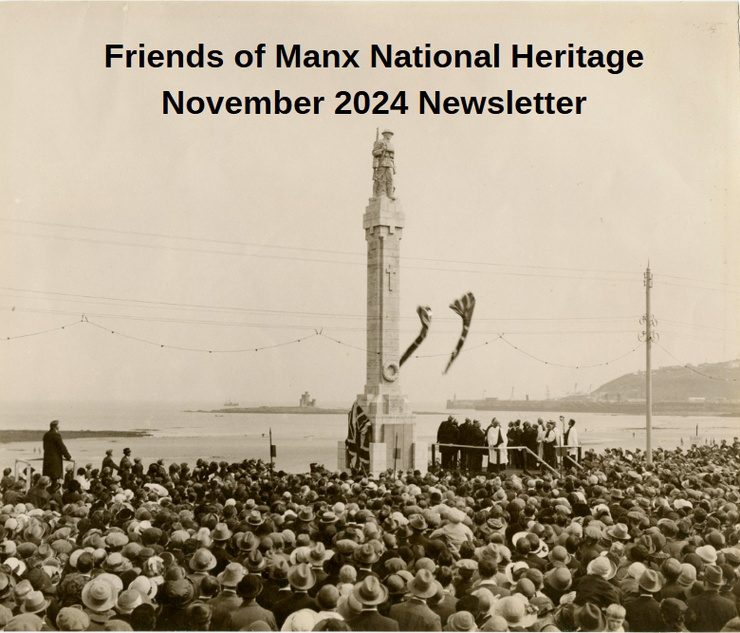

Dear Friends,

Welcome to your FMNH November newsletter. I am delighted to bring you updates and events exclusive to FMNH members. As always, you can find a full list of Manx National Heritage sites and their opening times on the [MNH](https://manxnationalheritage.im/visit-2/) website. Although MNH’s seasonal sites close for the winter after 3rd November, the Manx Museum and House of Manannan remain open all year and there’s plenty going on.

**Friends Event to Book Now**

**Illustrated Talk: ‘Foolish Fortnight - Yn Kegeesh Ommidjagh.’** Join former MNH Curator Yvonne Cresswell for our final event of the year to discover more about Manx Christmas customs from the chiollagh (cottage open hearth) to the local chapel, via the internment camps, harbours & the many streets of the Island. If you’ve attended any of Yvonne’s previous talks, you’ll know that she is always an entertaining and informative speaker. Join us in the Manx Museum shop afterwards for mince pies and last-minute Christmas shopping. **This is a free event, but numbers are limited to 40, so please contact me to reserve a place.**

**Date:** Thursday 19th December 2024, 10.30am.  **Price:** Free, donations welcome

**Venue:** The Manx Museum **Max Places:** 40

**To book your free place: Email** [**info@fmnh.im**](mailto:info@fmnh.im) **or call Emma 07624 243806**

**Friends Volunteers**

Huge thanks to all the Friends volunteers who helped out at both the Heritage Open Days and Hop tu Naa. Manx National Heritage are really grateful for our volunteers’ assistance. If you would like to learn more about being a FMNH volunteer, please contact Emma.

**Manx National Heritage Events and Exhibitions**

[**Labyrinth – All at Sea**](https://manxnationalheritage.im/whats-on/detail/labyrinth-all-at-sea/)**:** Manx National Heritage’s immersive historical theatre group, Labyrinth: History in Action, are back with a brand-new performance. *Labyrinth: All at Sea* will take place at the House of Manannan from **14 - 16 November 2024**. Inspired by the captivating nautical tales featured in the All at Sea exhibition, audiences are invited to dive into the legacy of Sir William Hillary, who dedicated himself to the creation of the Royal National Lifeboat Institution (RNLI). They will explore some of the gripping stories of life and loss around the Isle of Man’s coastline that inspired Hillary to galvanize support for a volunteer force that has saved countless lives at sea for over 200 years. This immersive theatrical experience offers a promenade-style performance, guiding the audience through the House of Manannan, where historical figures and true stories come to life. Audiences will be captivated by the salt-laden tales of adventure and peril, from the thrill of heroic rescues to the sombre realities of shipwrecks - and some rather enthusiastic reclaiming of lost cargo!

Stories explored will include the ‘wreck of the herring fleet’ in which 21 men died in a storm at the mouth of Douglas harbour. They had been fishing near Clay Head and ran for safe harbour at Douglas. The previous year the old pier had collapsed, and a temporary harbour light was set up on a pole, on the ruins, to guide the entrance. One of the first boats struck this light, extinguishing it and many of rest of fleet foundered on rocks in sight of the harbour.   The number of men injured is not known. Many vessels were damaged beyond repair with long term consequences for their owners.

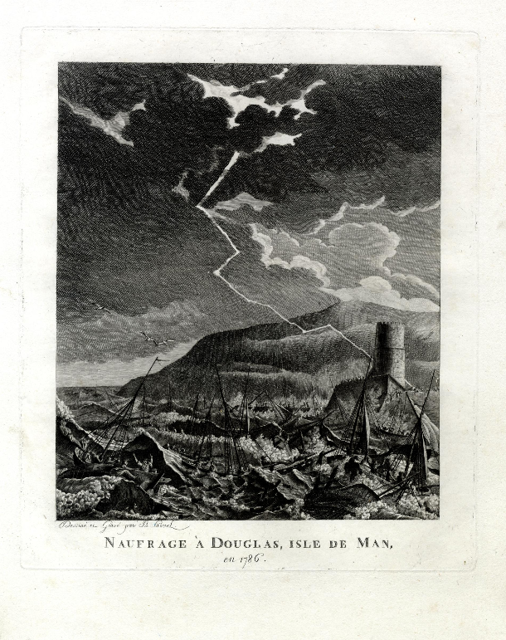

**Image: An illustration of the wreck of the herring fleet, 1787**

This fast-paced and interactive event promises to be a highlight of the season, so don’t miss your chance to embark on this remarkable journey. Gather your crew and prepare for a night filled with adventure, history and the spirit of the sea!

**The event takes place at the House of Manannan in Peel from 14 - 16 November 2024.  Performances commence at 5pm, 7pm and 8.30pm. Tickets £18, available online at** [**https://manxnationalheritage.im/whats-on**](https://manxnationalheritage.im/whats-on)

[**Manx Folklore – Rare Sightings and Urban Faeries:**](https://manxnationalheritage.im/whats-on/detail/manx-folklore-rare-sightings-and-urban-faeries/)Manx National Heritage invites you to step into the enchanting world of Manx fairy tales, myths and legends in ‘Rare Sightings and Urban Faeries’, an exclusive exhibition by illustrator Julia Ashby Smyth.

Inspired by some of the most popular characters from Manx folklore, the exhibition features over 70 magical creatures, believed to inhabit the Isle of Man’s landscape of bogs, waterfalls and hillsides, alongside lesser-known beings inhabiting the Isle of Man’s urban world.

Studying art at Ramsey Grammar School and North Staffordshire Polytechnic, Julia Ashby Smyth is a Manx illustrator who is at the heart of the Island’s art scene as curator of the Hodgson Loom Gallery at the Laxey Woollen Mills. Her distinctive illustrations are well known and much loved, appearing across the Island through many local commissions.

Working as an illustrator for over 40 years, Julia Ashby Smyth’s work has featured on Isle of Man stamp collections, coins and in well-known publications, including the new edition of Sophia Morrison’s Manx Fairy Tales. In recent years she has become known as the illustrator for Fynoderee Distillery.

**Image: The Faerey Cup, Graphite and white pencil.**

Original drawings, sketches, paintings and prints will be available to purchase throughout the exhibition period, offering a rare opportunity to own a unique piece of Julia Ashby Smyth’s work.

The exhibition at the Manx Museum runs until 23 February 2025. Open 9.30am – 4.30pm. Admission is free, with donations welcome.

**Fate Unknown: The Search for the Missing After the Holocaust:** Manx National Heritage is pleased to host a free day programme and exhibition provided by the [Wiener Holocaust Library](https://wienerholocaustlibrary.org/) and [Royal Holloway, University of Londo](https://en.wikipedia.org/wiki/Royal_Holloway,_University_of_London)n. The Wiener Holocaust Library is home to the UK’s International Tracing Service digital archive, which holds millions of documents related to the Holocaust and Nazi era. The archive preserves the shared past of victims and survivors of the Holocaust and helps support family research of Nazi persecution.

Archivists, historians, students, family historians, heritage practitioners, and anyone interested in Jewish and Holocaust history and its aftermath are welcome.

Learn about global efforts made after the Holocaust to find Zuzana Knobloch and millions of others like her. The work of the International Tracing Service (ITS) will be explored and connections made to the many Jewish refugees held as internees on the Isle of Man.

30th November 2024 11am – 3pm at the Manx Museum. Free, pre-booking essential. Book here: <https://bit.ly/3Uv7ugC>

**The Darker Skies of Mann with Howard Parkin:** Howard Parkin, who has been teaching for an amazing 40 years, will be joining MNH to explore the effects of excessive lighting, not just from an astronomical perspective, but also looking at the effects of on nature, wildlife, humans and the environment. Friday 13th December, 6pm at the Manx Museum. Tickets £15 available here: <https://manxnationalheritage.im/whats-on/detail/darker-skies-of-mann-howard-parkin/>

**P50 Competition at the House of Manannan:**

Manx National Heritage have filled the iconic little red P50 car on loan from[The Manx Transport Heritage Museum](https://www.facebook.com/ManxTransportHeritageMuseum) with gifts big, medium & small, with a few tiny ones added for good measure. Guess how many presents are inside and have a chance at winning an amazing prize.

Details: [P50 Christmas Competition at House of Manannan - Manx National Heritage](https://manxnationalheritage.im/whats-on/detail/p50-christmas-competition/)

**The World’s Largest Exhibition of Works by Archibald Knox**

**Archibald Knox (b.1864-d.1933) in his Douglas studio**

The world’s largest exhibition of works by Archibald Knox is set to be unveiled in a new exhibition showcased in the National Art Gallery at the Manx Museum. Opening Easter 2025, KNOX: Order & Beauty will feature over 200 pieces from collections across the British Isles, including rare pieces of silver, pewter and jewellery from iconic collections including the V&A, The Peartree Collection, Titus Omega, Manx National Heritage and major private collectors.

**To celebrate the forthcoming exhibition Manx National Heritage and the Archibald Knox Forum are inviting members of the public to nominate their own Knox designed piece, artwork or related artefact for inclusion in the exhibition. To nominate a piece from your private collection please email** [**collect@mnh.im**](mailto:collect@mnh.im)**, including a photograph of your object, a short reason why you feel it should be in the exhibition and the dimensions of the piece. From the submissions ten objects will be chosen to form the ‘People’s 10’ display in the gallery.   The competition is only open to Isle of Man residents, with entries closing at midnight on Sunday 24 November.**

The exhibition will open at the Manx Museum in Douglas on 5 April 2025 until 1 March 2026. It will form part of a wider ‘Isle of Knox’ campaign, supported by the Isle of Man Government’s Visit Isle of Man Agency, with associated events, walks and talks dedicated to exploring the life and works of Archibald Knox taking place in 2025 and early 2026. <https://manxnationalheritage.im/whats-on/detail/knox-order-beauty/>

**Christmas Shopping with Manx National Heritage**

[**Christmas Hygge**](https://manxnationalheritage.im/whats-on/detail/christmas-hygge-artisan-fair-with-artreach-studios/)**: Artisan Fair with Artreach Studios:** Step into a world of festive delights at the annual Christmas Hygge Artisan Fair, organised by Artreach Studios. Pick up some fabulous gifts in MNH’s heritage shop, meet the makers on arts and craft stalls, and purchase quality handmade gifts from some of your favourite local artists including artworks, ceramics, textiles, prints, cards, jewellery and more.

This event will take place across three locations:

**15th November**- Artreach Studios and the Pilates Studio on Mill Road.

**16th and 17th November** – House of Manannan, Artreach Studios and the Pilates Studio on Mill Road.

**Time**: 9.30 - 4.30

<https://manxnationalheritage.im/whats-on/detail/christmas-hygge-artisan-fair-with-artreach-studios/>

**Manx National Heritage Christmas Cards**

Available online at the MNH shop, these are available in packs of 10 featuring 2 different Manx Christmas scenes (*The Goose Fair* by Franz Hoepfner and *Peel Church December 1890* by George Goodwin) priced at £6 per pack. <https://manxnationalheritage.im/shop/>

**Manx National Heritage Calendars**

The MNH Calendar is back in stock: <https://manxnationalheritage.im/shop/product/2025-manx-national-heritage-calendar/>

**Friends of Manx National Heritage Discounts**

Don’t forget you can get 10% discount on non-commission items in the Manx National Heritage shops at the Manx Museum and House of Manannan on production of your Friends of Manx National Heritage card. They have some great Christmas gifts and decorations and your purchases help to preserve our island’s unique heritage.

Your membership is vital to our mission, and we are grateful for your continued support. Together, we are safeguarding the heritage of the Isle of Man for future generations to cherish.

Please contact Emma [emma@fmnh.im](mailto:emma@fmnh.im) or 07624 243806 if you would like any more information about our events and news.

Kind regards,

***Emma***

**Website**: Friends of Manx National Heritage <https://www.friendsofmnh.org/>

**Follow our Facebook page**: <https://www.facebook.com/friendsofmnh/>

**Follow our LinkedIn page:** <https://www.linkedin.com/company/friends-of-manx-national-heritage/>

**Follow us on Instagram:** friendsofmnh