Dear Friends,

Welcome to your FMNH February newsletter. I am delighted to bring you updates and news of FMNH Member exclusive events. As always, you can find a full list of Manx National Heritage sites and their opening times on the [MNH](https://manxnationalheritage.im/visit-2/) website. There is plenty going on in 2025, including a major Archibald Knox exhibition with a series of linked events.

**Friends of Manx National Heritage 2025 Events**

Exciting new member events are on their way for 2025! I have been working behind the scenes with our wonderful museum staff and local experts on a programme of exclusive members only talks and tours for the coming year and I can't wait to share them with you.

**Book Now!**

**Thursday 27th March - Not quite taxidermy: Bird Skins.** Join MNH Curator of Natural History Laura McCoy to have a look through a little seen part of MNH’s collection, learn about their preparation and purpose, and how they contribute to science and conservation.

**Venue:** The Manx Museum. **Time:** 11.00 Price: £10 per person plus optional donation to FMNH.

**To book:** email [info@fmnh.im](mailto:info@fmnh.im) or call Emma on 07624 243806.

**Thursday 24th April -** **KNOX: Order & Beauty**. Join MNH Curator Katie King on an exclusive tour of the world’s largest ever exhibition celebrating Archibald Knox. Learn more about how the MNH team brought the show together and discover stories behind some of the objects on display.

**Venue:** The Manx Museum. **Time:** 11.00 Price: £12 per person plus optional donation to FMNH.

**To book:** email [info@fmnh.im](mailto:info@fmnh.im) or call Emma on 07624 243806. ~~ONLY 20 PLACES AVAILABLE,~~ this event is for FMNH Members only. **SOLD OUT – WAITING LIST IN OPERATION**

**Please note, booking information will be released closer to the time for the following events:**

**May: Of Monarchs and Man.** Join MNH Archivist Wendy Thirkettle to learn aboutRoyal visits to the island since 1847. Illustrated talk using resources from the library’s collections.

**June: Conservation of the Manx National Heritage collections.** Join MNH Collections Conservation Manager Christopher Weeks in the galleries of the Manx Museum to learn about the amazing conservation of some iconic objects.

**July: Join us for a special guided tour of the beautiful gardens at Rushen Abbey** with Philip Payne, Horticultural Manager for Manx National Heritage. Discover how naturalistic planting enhances the historic setting, learn about the carefully selected plant species, and gain insight into the evolving design of this tranquil space. This is a fantastic opportunity to explore the gardens in their peak season and hear directly from the horticulturist responsible for their care.

**August: The 1961 TT Races.** Honda recently supplied to MNH a documentary made by their own Honda archives. The first part of the talk by MNH Curator Matthew Richardson will introduce the main characters followed by a screening of the full 30-minute documentary.

**September:** **Bride and Jurby gems.** Illustrated talk by MNH Archivist Wendy Thirkettle using resources from the library’s collections to illuminate these parishes’ fascinating history.

**October:** **Living With the Wire - Internment in the First World War**. Yvonne Cresswell’s talks about internment are always informative and entertaining. Last year we enjoyed learning about Internment in the Second World War. This year we will be travelling back to the Great War.

**November**: **The Isle of Man’s National Treasures with Allison Fox**. Join MNH Curator: Archaeology Allison Fox at the House of Manannan to learn the hidden stories behind some of the Island’s most stunning archaeological artefacts.

**December:** **Watch and Ward on the Isle of Man.** Rescheduled from last year, Andrew Johnson, MNH Curator of Archaeology ‘s talk will offerdocumentary and landscape perspectives on a medieval and post-medieval coastal watch system.

Keep an eye out for our newsletters and take a look at our [website](https://www.friendsofmnh.org/events/) for booking information as it is released.

**Donations**

Huge thanks to Lloyds Bank International for their very generous donation of £250 to the Friends of Manx National Heritage. Staff at Lloyds Bank in Douglas donate money from their salaries each month in order to be able to nominate local charities that they would like to see benefit from the funds. Every donation helps to directly preserve our unique cultural heritage through funding for projects, acquisitions and conservation, so that everyone can enjoy all aspects of our Island’s heritage.

You can donate to FMNH here: [https://www.friendsofmnh.org/about-us/](https://www.friendsofmnh.org/about-us/?fbclid=IwZXh0bgNhZW0CMTAAAR09-jKN2_Eq6McAL47RB--6_0EGUQxMdZpJVFX4Bs8XKJLYDAB35vJa5wM_aem_NAoAGRt8ygFywreDtlJCkA)

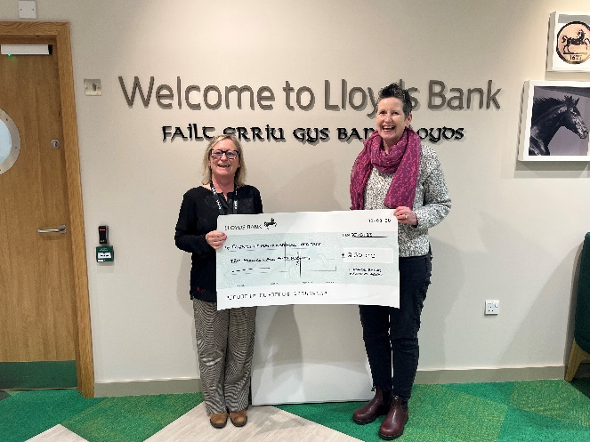

**L to R: Sam Mahon of Lloyds Bank and Emma Morter of FMNH**

**Legacies**

We were recently very fortunate to receive a £500 legacy from the estate of one of our Life members. If you would like to make a lasting difference to our Island’s unique heritage and culture, would you consider leaving a legacy to FMNH in your will? Please contact me for more information.

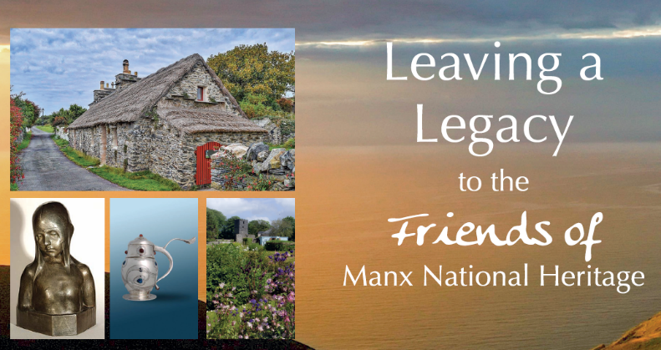

<https://www.friendsofmnh.org/legacies/>

**George Martin Ramsey Moore M.B.E**

The Directors of the Friends of Manx National Heritage were very sad to hear of the recent death of George Ramsey Martin Moore M.B.E. Known as Martin, he was a great supporter of Manx history and culture and a former Director of the Friends.  
Martin's family have asked that donations in lieu of flowers be made to the Friends of Manx National Heritage.  
Martin's obituary can be found here: [**https://bit.ly/418XHR2**](https://bit.ly/418XHR2?fbclid=IwZXh0bgNhZW0CMTAAAR3uRhXtr1IvmnuhxCEQdNRUZG8L2OC-GL1GtrIOdY3N8W1vPW2Rx65oxYk_aem_ZdUw72P_Vgb4WS_Ayop_OA)  
If you would like to make a donation to FMNH, please visit our website [**https://www.friendsofmnh.org/**](https://www.friendsofmnh.org/?fbclid=IwZXh0bgNhZW0CMTAAAR1EesGUXuz74uI4PjpNY7I5n6crgvizToZjvQYiPGMzzXK5s2RTwpyfuJQ_aem_Nx5OjVHJAQz99HBuB_TvRg) or contact [emma@fmnh.im](mailto:emma@fmnh.im)

**Manx National Heritage Exhibitions and Events**

**6 'Ways of Seeing':** I was fortunate enough to be invited on Saturday to the opening of the 6 'Ways of Seeing' Exhibition at the House of Manannan. This art exhibition showcases the work of six very different Island artists: Ellie Baker, Sally Black, Helen Faragher, Petrina Kent, Ella Magee, and Ongky Wijana. There really is something for everyone, from beautiful sculpture and stone carving to landscapes and studies of our local nature, so I urge you to visit and see for yourself. **Date: Now until 27/04/2025** at the House of Manannan. Free admission – Donations welcome.

**Gaiety 125:** An exhibition celebrating the 125th anniversary of one of the Isle of Man’s most loved buildings, the Frank Matcham designed Gaiety Theatre. **Date: 25/01/2025 -18/05/2025.** 9.30am - 4.30pm at the Manx Museum. Free admission – Donations welcome.

**‘Hear Us’: Sounds of the Sea:** Discover the sounds beneath the surface of the waters surrounding the Isle of Man and gain a new appreciation of the Island’s rich and varied marine life. **14/12/2024 — 30/03/2025** at the Manx Museum. Free admission – Donations welcome.

**Event - ‘Hear Us’: Listen and Learn About our Island’s Waters:** Meet the people behind the inspirational ‘Hear Us: Sounds of the Sea exhibition, listen to the Island’s underwater world and have a go at recreating the vintage art of pressing seaweed. **Date: 29/03/2025 10.00** **or 11.00** at the Manx Museum. £8 per person. Bookings: <https://manxnationalheritage.im/whats-on/detail/hear-us-listen-and-learn-about-our-islands-waters/>

**Event – KNOX: Order & Beauty Launch Seminar Day:** To celebrate the launch of KNOX: Order & Beauty, Dr Stephen Martin, Anthony Bernbaum, and Paul Carter Robinson will be delivering a series of lectures at the Manx Museum in this unique day seminar. There will be lots of opportunities for questions and answers, with time to explore the exhibition. **Date:** **05/04/2025** and **06/04/2025,** 11am - 6:30pm. Tickets £20 <https://manxnationalheritage.im/shop/product/knox-order-beauty-launch-seminar-day-5th-april-2025/>

**Archibald Knox Order & Beauty:** In 2025 the world’s largest exhibition of works by Archibald Knox is set to be showcased in the National Art Gallery at the Manx Museum. ‘Knox: Order & Beauty’ will open on **5th April 2025**. There will also be a whole host of special events to accompany the exhibition, including a series of talks, tours and walks in the footsteps of Archibald Knox – see MNH website for more details: <https://manxnationalheritage.im/whats-on/>

**Leonard McCombe: Through the Lens of War:** Leonard McCombe was one of the Isle of Man’s most successful photographers, producing some of 20th Century’s most iconic images. To mark the 80th anniversary of VE Day, explore his war photography; many of the images have never been seen before, and all are a testament to the reality of war. **Date:** **09/05/2025 - 05/10/2025.** 9.30am - 4.30pm at the House of Manannan. Free admission – Donations welcome.

**‘No Limit’ at 90:** An exhibition marking the 90th anniversary of the release of one of the Isle of Man TT’s best loved tributes. The 1935 film 'No Limit' starred Britain’s top comedian at that time, George Formby, as aspiring TT rider George Shuttleworth. **Date:** **24/05/2025 - 07/09/2025.** 9.30am - 4.30pm at the Manx Museum. Free admission – Donations welcome.

Your membership is vital to our mission, and we are grateful for your continued support. Together, we are safeguarding the heritage of the Isle of Man for future generations to cherish.

Please contact Emma [emma@fmnh.im](mailto:emma@fmnh.im) or call me on 07624 243806 if you would like any more information about our events and news. I work part time, but if you leave me a message, I will return your call as soon as I can.

Kind regards,

***Emma***

**Website**: Friends of Manx National Heritage <https://www.friendsofmnh.org/>

**Follow our Facebook page**: <https://www.facebook.com/friendsofmnh/>

**Follow our LinkedIn page:** <https://www.linkedin.com/company/friends-of-manx-national-heritage/>

**Follow us on Instagram:** friendsofmnh