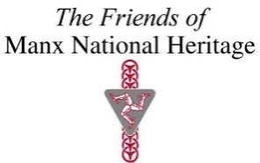

The 15th ANNUAL GENERAL MEETING
of
The Friends of Manx National Heritage (company number 122324C)
to be held at 11.00am on Saturday 8th November 2025
at the Manx Museum, Kingswood Grove, Douglas.

NOTICE AND AGENDA

1. To confirm the appointment of Mr. Michael Crowe as Chairperson of the meeting in accordance with Article 15 of the Charity’s Articles of Association.

2. To table and receive the minutes of the Annual General Meeting of the Friends of Manx National Heritage held at the Manx Museum on Saturday 9th November 2024.

3. Chairman’s introduction and report.

4. To receive the Treasurer’s report.

5. To consider a resolution to adopt accounts for the period ended 31st March 2025.

6(1). To note the retirement of the following directors by rotation and, having expressed their willingness to continue to serve, to consider a resolution for their reappointment to the board:
(Mrs Mary Bridson and Mr. Michael Crowe)
6(2). To note the retirement of Miss Alison Moore

7. Appointment of Auditor:

To consider and if thought fit approve the re-appointment of Ms. Phaedra Bird of Crowe Isle of Man LLC as auditor.

8. To receive the report from Manx National Heritage.

9. Any other business.

Please note that all relevant documents for the AGM will be posted on our website https://www.friendsofmnh.org/ If we don’t have your up-to-date email and you would like to request these, please contact info@fmnh.im

If you wish to receive these documents by post, please call Emma Morter on 07624 243806.

