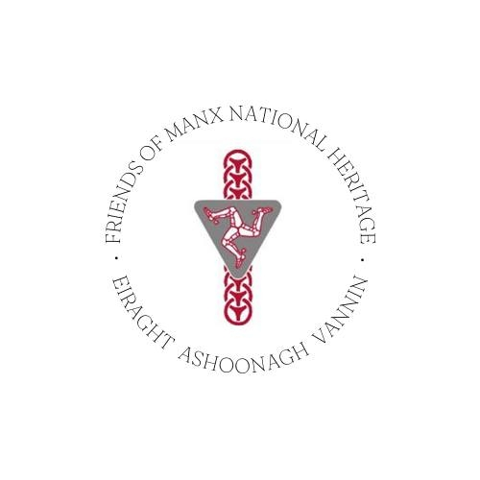
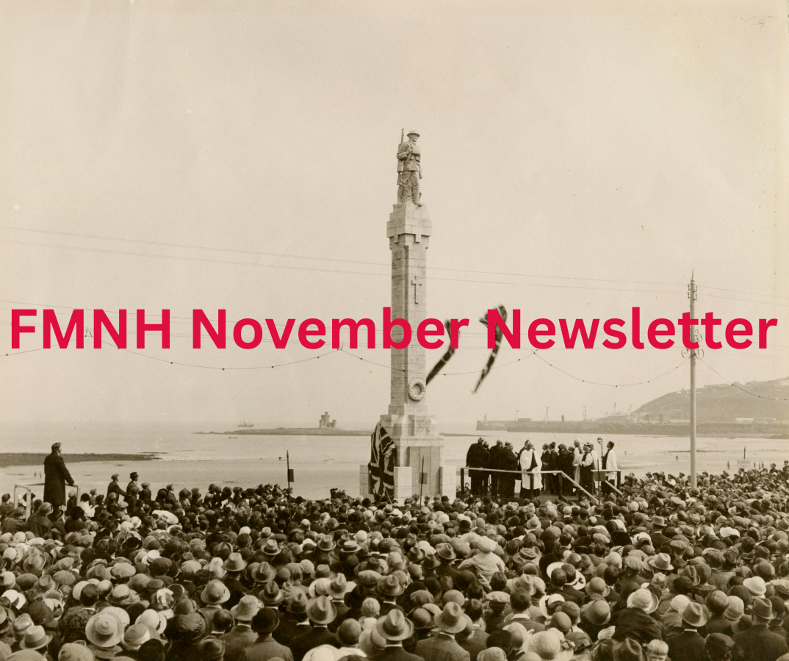
Image: iMuseum http://bit.ly/4otTj87

Dear Friends,
Welcome to your FMNH November newsletter. I am delighted to bring you updates and news of FMNH Member exclusive events. As always, you can find a full list of Manx National Heritage sites and their opening times on the MNH website. Manx National Heritage seasonal sites closed for the winter on 2nd November. The Manx Museum and House of Manannan remain open throughout the year.
FMNH Member Event – December
Thursday 18th December: Illustrated Talk - Watch and Ward: for hundreds of years before radar and telescopes, it was a legal requirement for Manxmen to keep an organised watch out to sea for signs of potential trouble. MNH archaeologist Andy Johnson will review the known facts about this system of watch-keeping and present new evidence for where the watch-sites were located and how the network, and the way it operated, changed through time.
Venue: The Manx Museum. Time: 10.30am. Price: £10 per person plus optional donation to FMNH.
To book: email info@fmnh.im or call us on 07624 243806.
FMNH Team News
Emma Morter will be leaving the Friends on 20th November 2025, as she is moving back to the UK after two years in post as our extremely efficient Administrator and Development Officer. The Directors express their thanks to Emma for ensuring the smooth running of the FMNH. We wish you all the best for your next chapter, Emma!

Emma Morter
We are delighted to announce that Hannah Murphy will be taking over as Administrator and Development Officer. Hannah has previously had a long career with Manx National Heritage and is very knowledgeable and enthusiastic about our Island’s unique history and heritage. Hannah is currently working alongside Emma so she can learn the ropes and will be out and about at Friends events, so some of you will get the chance to meet her. I’m sure you’ll join us in welcoming Hannah and wishing her every success in her new role. Hannah’s email address is hannah@fmnh.im if you need to get in touch.
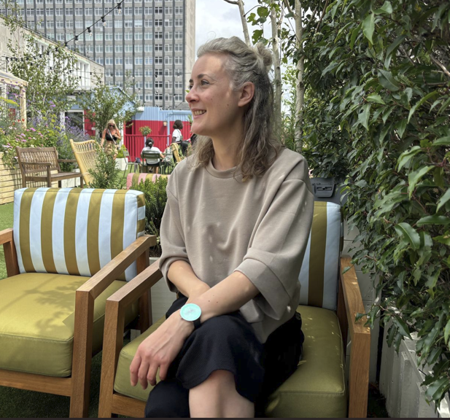
Hannah Murphy
Manx National Heritage Exhibitions and Events
New Exhibition – National Treasures: From rare Bronze Age jewellery to Viking silver and gold, discover the Isle of Man's National Treasures in this new exhibition. House of Manannan 25/10/2025 to 01/02/2026. Free, donations welcome.
Illustrated Talk - Annie Swynnerton: Artist, Activist, Pioneer, illustrated talk by Rebecca Milner, Curator: Fine Art, Manchester Art Gallery. When elected to the Royal Academy in 1922, it was a male – only club and Annie was the first woman to be admitted since its foundation 154 years earlier. Explore the trailblazing work of Annie Swynnerton as a painter and women’s rights campaigner at Manx National Heritage’s joint lecture with the Isle of Man Victorian Society. 22/11/2025 at the Manx Museum. Free, donations welcome. Tickets: http://bit.ly/4oAoyOE

Exhibition - Knox: Order & Beauty: this free landmark exhibition celebrating the life and work of Archibald Knox continues at the Manx Museum and is well worth a visit. There is also a series of Knox themed walks and tours to enjoy. Details: https://manxnationalheritage.im/whats-on/

Please see Manx National Heritage’s website for more events and exhibitions: https://manxnationalheritage.im/whats-on/
If you have any questions about your membership, please contact us. We work part-time, but we will always answer your queries as soon as we can.
Kind regards,
Emma and Hannah
Emma Morter and Hannah Murphy
Development Officers and Administrators
Tel.: 07624 243806
Website: Friends of Manx National Heritage https://www.friendsofmnh.org/
Follow our Facebook page:https://www.facebook.com/friendsofmnh/
Follow our LinkedIn page: https://www.linkedin.com/company/friends-of-manx-national-heritage/
Follow us on Instagram: friendsofmnh
Isle of Man Registered Charity No. 1027

